M-blocks Robots – A bot complete in Itself

*-Sancheeta Kaushal (3rd year B. Tech. Student)-Jaypee University of Information Technology*

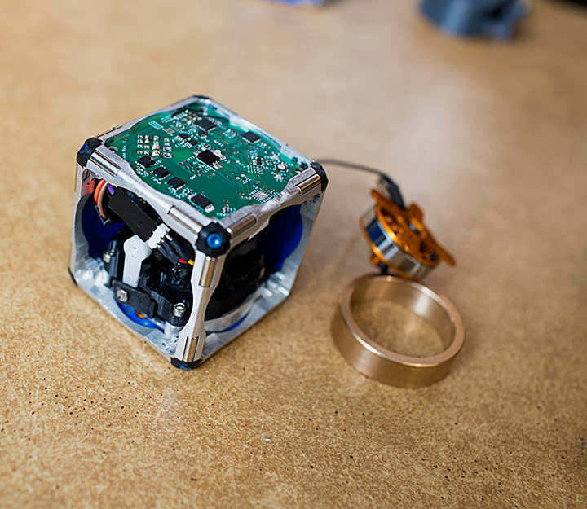Let’s imagine a world where robots can assemble to make a wall, bridge or shelter during a calamity or emergency situation or could be formed into a chair, a ladder, or a desk, on demand. Let’s stop here and start from beginning with what kind of robots do we expect and what kind of robot is available as of now. Well the difference between the two is huge.

**What we have is-**

Huge machines that work on specific tasks.

Robots those are architecture specific.

**What we expect is-**

Super smart robots that can modify according to our needs, as and when required.

Robots that are light weight and can change its shape, leap, self-assemble and climb by self on any terrain.

So what we want is basically modular robots.

And the questions are-

**What are they?** Basically these are modular self-reconfiguring robotic systems are autonomous [kinematic machines](http://en.wikipedia.org/w/index.php?title=Kinematic_machine&action=edit&redlink=1) with variable [morphology](http://en.wikipedia.org/w/index.php?title=Morphology_(materials_science)&action=edit&redlink=1).

**Why do we need them?** Because they are able to deliberately change their own shape by rearranging the connectivity of their parts, in order to adapt to new circumstances, perform new tasks, or recover from damage.

**Which type of modular robots are we talking about and what makes them different?** M-blocks – these robots are cubes without any external moving parts while other modular bots in past used arms. These can flip, leap through air, roll across the ground and jump over each other without wheels, legs or arms.

**How M-blocks work?** Well these bots work on basic principles of angular momentum and smart tricks applied on magnets. A flywheel with 20000 rpm when stopped, transfers its angular momentum to the cube that’s each edge and face has permanent magnets.

With each edge equipped with two cylindrical magnets which naturally rotate and north poles aligns with south and vice versa. “Any face of any cube can thus attach to any face of any other.”

The cube’s edges are bevelled, when cubes are face to face, a slight gap between magnets still exists. When one cube begins to flip on top of another, the bevels, and hence the magnets, come in contact and then two cubes tend to adhere strongly. There are four more pairs of smaller magnets on each face arranged symmetrically, which help to put a moving cube into place when it places itself over other one.

Right now they are being controlled by radio frequency and Wi-Fi signals with variety of algorithms being implemented.

The scope is too wide to be explained here but a day is not far when the modularization meets miniaturization and we may have tiny little bots as small as that of sand grain combining to form a huge robot.

